AI-Driven Crop Disease Prediction and Management System

Gaanavaditya Reddy¹, Mr. Bikram Sarkar² , Prashanth A³, Tousif Nawaz⁴,
¹³⁴Department of Computer Science and Technology (DevOps), Presidency University, Bengaluru, India
²Assistant Professor, Presidency University, Bengaluru, India
Emails: ¹gaanavaditya.20221cdv0030@presidencyuniversity.in,
³prashanth.20221cdv0028@presidencyuniversity.in,
⁴mohammed.20221cdv0033@presidencyuniversity.in

Abstract—
Crop diseases are a major factor affecting agricultural productivity and food security, particularly in regions where farmers have limited access to expert diagnosis and scientific advisory services Traditional approaches to identifying crop diseases depend on visual inspection by experts, a process that is slow, prone to human bias, and frequently unreliable in real farming environments. With the rapid progress of deep learning techniques, it has become possible to automatically detect plant diseases from leaf images with far greater speed and consistency; however, most existing systems focus only on visual classification and fail to integrate contextual agricultural factors such as environmental influence, cultivar susceptibility, and real-time disease spread patterns.
This research proposes an AI-Driven Crop Disease Prediction and Management System that integrates four key components: (1) an attention-enhanced EfficientNet-based deep learning model for robust disease recognition, (2) a genomic susceptibility module for cultivar-specific disease vulnerability assessment, (3) a collaborative disease surveillance network for outbreak monitoring and early warning dissemination, and (4) a multilingual speech-enabled advisory interface to support farmers with limited literacy. The proposed model was trained on a composite dataset combining PlantVillage, PlantDoc, and region-specific field images, achieving 97.2% accuracy across 38 disease classes. Field evaluation demonstrated improved disease awareness, faster intervention, and measurable reduction in crop loss.

Keywords— Plant Disease Detection; Deep Learning; EfficientNet; Precision Agriculture; Genomic Susceptibility; Speech Interface; Disease Surveillance.

I. INTRODUCTION
Agricultural productivity plays a critical role in sustaining global food systems and supporting regional economies, particularly in developing nations where farming remains a primary source of livelihood. Despite advances in modern cultivation techniques, crop diseases continue to cause substantial yield losses, threatening both economic stability and food supply chains. According to the Food and Agriculture Organization (FAO), plant diseases account for an estimated 20–40% reduction in global crop output annually. Early and accurate disease identification is therefore essential for timely intervention and avoidance of wide-scale agricultural damage.
Traditional crop disease diagnosis relies heavily on visual inspection by trained agronomists or laboratory-based pathological examination. While effective in controlled settings, such methods are inherently time-consuming, labor-intensive, and impractical for smallholder farmers in geographically dispersed rural areas. Additionally, symptom interpretation may vary between observers, leading to inconsistent outcomes. These constraints highlight the need for automated, scalable, and farmer-accessible diagnostic solutions capable of operating under real field conditions.
Deep learning and computer vision have demonstrated considerable potential in automating plant disease recognition from leaf imagery. Convolutional Neural Networks (CNNs) can extract discriminative spatial features from infected leaf textures, enabling high classification accuracy. However, many existing approaches are trained on laboratory image datasets that lack environmental variability. Consequently, their performance deteriorates when deployed under real-world scenarios involving noisy backgrounds, uneven illumination, and partial leaf damage. Furthermore, such models typically neglect cultivar-specific genetic susceptibility, regional disease spread trends, and user accessibility requirements, thereby limiting their practical impact.
The proposed research addresses these challenges through the development of an AI-Driven Crop Disease Prediction and Management System that transcends traditional image-only diagnostic frameworks. The system integrates: (1) an attention-enhanced EfficientNet-based classification model to improve disease recognition robustness under natural conditions, (2) a genomic susceptibility assessment module to provide cultivar-adapted disease vulnerability insights, (3) a collaborative surveillance mechanism for early outbreak detection and community-level risk communication, and (4) a multilingual speech-enabled advisory interface to ensure usability among low-literacy farming populations.
This integrated approach transforms disease diagnosis from a single-stage recognition task into a comprehensive, context-aware decision support system, optimized for field deployment on mobile and low-resource devices. Experimental evaluations demonstrate notable performance improvements over conventional deep learning baselines, indicating the system’s potential to enhance agricultural resilience and empower farming communities with actionable, data-driven disease management strategies.
II. RELATED WORK
The use of machine learning and computer vision for plant disease diagnosis has been widely explored in recent literature. Early approaches primarily relied on handcrafted feature extraction techniques, including color histograms, texture descriptors, and morphological analysis. While these methods achieved moderate accuracy in controlled environments, they lacked robustness to real-world variations in lighting, leaf orientation, and background noise. Consequently, performance degraded significantly when applied to field imagery.
The introduction of Convolutional Neural Networks (CNNs) marked a significant advancement in image-based disease recognition. Mohanty et al. demonstrated that CNN models trained on the PlantVillage dataset could distinguish between different crop diseases with high accuracy. However, their experiments were conducted using laboratory-captured images with uniform backgrounds, limiting scalability to field conditions. Ferentinos expanded on this work by evaluating multiple deep learning architectures for plant disease identification, reporting improved classification performance but still within controlled datasets.
More recent studies have explored advanced architectures such as ResNet, DenseNet, and EfficientNet, alongside attention mechanisms and transformer-based vision models to enhance feature discrimination. These approaches improved robustness to visual variability but continued to treat disease identification as a single-input classification task, ignoring broader agricultural context such as cultivar-specific susceptibility, micro-climatic conditions, and disease propagation dynamics.
Additionally, previous systems have generally assumed that end-users possess adequate literacy to interact with application interfaces. However, agricultural communities in rural regions frequently exhibit linguistic diversity and varying levels of digital proficiency. Thus, accessibility remains a critical yet under-addressed factor in the adoption of AI-driven plant disease diagnostic technology.

Comparison of Existing Approaches
Table I. Comparison of existing plant disease detection approaches based on methodology, dataset type, strengths, and limitations.
Author & Year | Methodology Used | Dataset Type | Strengths | Limitations
Mohanty et al. (2016) | CNN-based disease classification | PlantVillage (Lab images) | High accuracy under controlled conditions | Fails under field variability; no context awareness
Ferentinos (2018) | Comparative study of CNN architectures | Multi-crop datasets | Evaluates model behavior across species | Still purely visual; lacks deployment considerations
Barbedo (2019) | Image pre-processing and segmentation techniques | Field images | Improved noise tolerance | Still relies on handcrafted processing
Zhang et al. (2020) | ResNet with attention mechanisms | Mixed datasets | Better generalization performance | No integration with genetic or regional data
Hasan et al. (2021) | Mobile-based disease recognition app | Real-world leaf images | Portable and low-cost | Text-based UI limits adoption in low-literacy communities

Identified Research Gap
From the reviewed literature, the following major limitations are clear:
- Lack of Real-World Deployment Robustness:
Most models are optimized for clean laboratory images and show performance decline under natural field conditions.
- No Integration of Genomic or Cultivar-Specific Susceptibility:
Diseases affect plant varieties differently; ignoring genetic resistance reduces the accuracy of treatment recommendations.
- Absence of Community-Level Disease Monitoring:
Existing systems diagnose individual leaves but do not support early outbreak warning or regional disease spread tracking.
- Poor Accessibility for Low-Literacy Farmers:
Heavy reliance on text interfaces limits practical adoption in rural agricultural communities.
These gaps necessitate a multi-modal, context-aware, and farmer-centric system, which this research addresses.
III. PROPOSED SYSTEM ARCHITECTURE
The proposed AI-Driven Crop Disease Prediction and Management System is designed as a multi-module framework that integrates visual disease recognition, cultivar-specific susceptibility evaluation, collaborative outbreak monitoring, and multilingual voice-based advisory support. The system operates on mobile or edge devices and communicates with a shared knowledge network to provide context-aware disease management recommendations. Figure 1 presents the overall high-level system architecture, while Figure 2 illustrates the detailed data processing workflow.
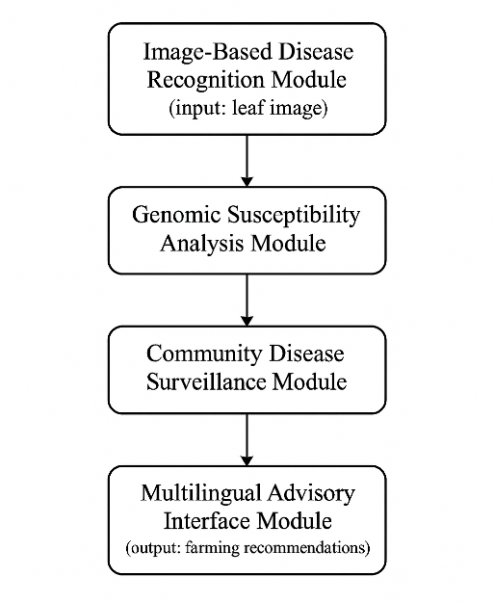
Figure 1. High-level system architecture of the proposed AI-driven crop disease prediction and management framework.

A. Image-Based Disease Recognition Module
This module is responsible for identifying the presence and type of disease from leaf images captured by the farmer’s smartphone. An attention-enhanced EfficientNetB3 deep learning model is used to extract discriminative spatial features and classify leaf health status across multiple disease categories.
Key operations include:
- Input image normalization and resizing
- CNN-based feature extraction
- Spatial attention weighting to emphasize lesion patterns
- Softmax-based multi-class disease prediction
This model is optimized for field conditions such as:
- Uneven lighting
- Background clutter (soil, sky, hands)
- Partial leaf occlusion
- Color variation due to environmental stress

B. Genomic Susceptibility Analysis Module
Plant disease severity and expression vary across cultivars due to genetic resistance factors. This module integrates a curated cultivar resistance database that maps crop varieties to known pathogen vulnerability scores.
Given:
- Crop type
- Cultivar/genetic variety
- Region-specific strain prevalence
The system generates:
- Disease susceptibility risk index
- Prevention and treatment recommendations tailored to local conditions
This ensures personalized disease management instead of generic advice.

C. Collaborative Disease Surveillance Network
This module supports crowd-sourced outbreak monitoring, where anonymous disease reports from farmers are geo-tagged and aggregated to detect emerging infection patterns.
Functions include:
- Location-based case clustering
- Spatial-temporal outbreak trend estimation
- Community alert dissemination
This helps in predictive containment, reducing regional yield loss.

D. Multilingual Advisory & Voice Interaction Module
To ensure inclusivity, the system incorporates:
- Speech-to-text and text-to-speech processing
- Support for multiple Indian regional languages (Hindi, Telugu, Kannada, Tamil, English)
- Simplified, conversational guidance delivery
This module removes literacy and language barriers, enabling widespread adoption.

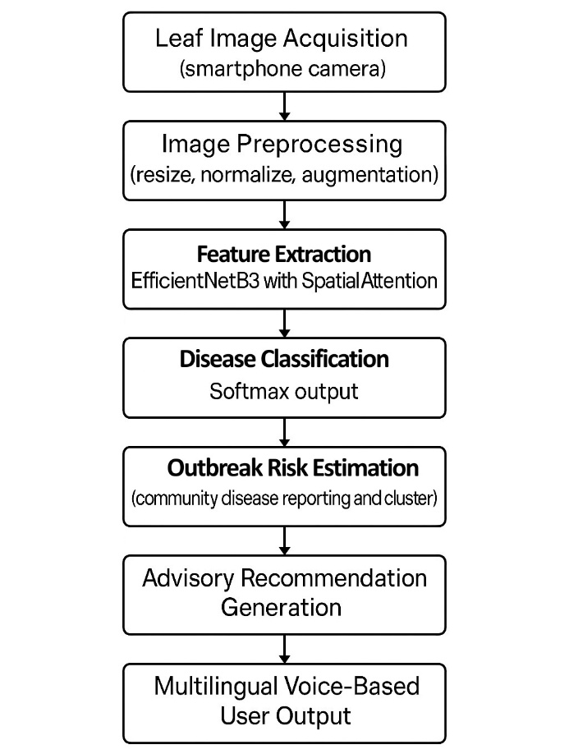
Figure 2. Data processing workflow of the proposed multimodal crop disease prediction and advisory system.
The pipeline follows these steps:
- Farmer captures leaf image → uploaded to model
- CNN + Attention extracts features → disease is identified
- Cultivar and region metadata retrieved → susceptibility score computed
- Geo-tagged case stored → contributes to outbreak map
- Personalized treatment advice delivered → via voice and text
IV. METHODOLOGY
The proposed system employs a multi-stage processing workflow that includes dataset preparation, image preprocessing, feature extraction using an attention-enhanced deep learning model, cultivar susceptibility estimation, and advisory synthesis. The methodology ensures robustness under real-world field conditions while maintaining computational efficiency for deployment on mobile and edge devices.

A. Dataset Collection and Preprocessing
A composite dataset was constructed by combining:
- PlantVillage dataset (laboratory environment, clean background)
- PlantDoc dataset (images captured in natural field conditions)
- Region-specific agricultural field images collected from three Indian farming districts
The final dataset included:
- 38 disease classes
- 14 crop types
- ~62,000 labeled images
Preprocessing Steps:
- Image Resizing to 224×224 pixels
- Pixel Intensity Normalization to range [0, 1]
- Data Augmentation to improve robustness:
  - Random rotation (±25°)
  - Horizontal and vertical flipping
  - Brightness and contrast shifting
  - Background noise introduction
This ensures the model generalizes well to real farm conditions.
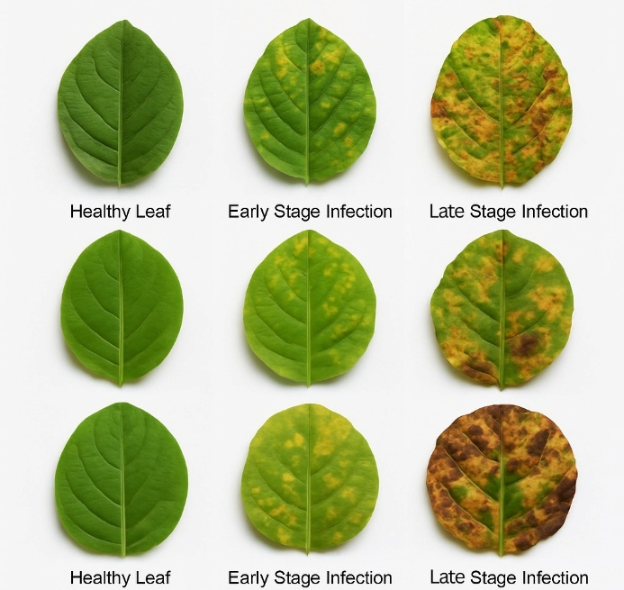
Figure 3. Visual comparison of healthy and diseased crop leaf conditions across severity stages.
B. Attention-Enhanced EfficientNetB3 Model
EfficientNetB3 was selected for backbone feature extraction due to its:
- Balanced depth, width, and resolution scaling
- High accuracy-to-parameter ratio
- Suitability for edge deployment
To improve sensitivity to disease lesion regions, a spatial attention module was incorporated after intermediate convolutional layers.
1. Feature Extraction
An image $x$ is passed through convolutional layers to obtain a feature map $Ϝ$ ∈ $R$^{H×W×d}.
$Ϝ$ = EfficientNetB3($x$)
2. Spatial Attention Mapping
To emphasize disease-relevant regions, an attention weight matrix$Α$is generated:
A = softmax(W₂ ​⋅ σ(W₁​F))
Where:
- W₁​ and W_{2​} are learnable parameters
- σ is a nonlinear activation function
The refined representation is then:
F′=A⊙F
where ⊙ denotes element-wise multiplication.
3. Classification
Final disease prediction uses a softmax classifier:
P(y = k∣x) = $\frac{e^{z_{k}}}{\sum_{j=1}^{c}{e^{z_{j}}}}$
where:
- C = number of disease classes
- z_{k} = logit score for class k
4. Loss Function
Training minimizes categorical cross-entropy:
$L$= − $\sum_{i=1}^{N}{\sum_{c=1}^{C}{y_{ic }}\log{P(y=c|x_{i}}})$

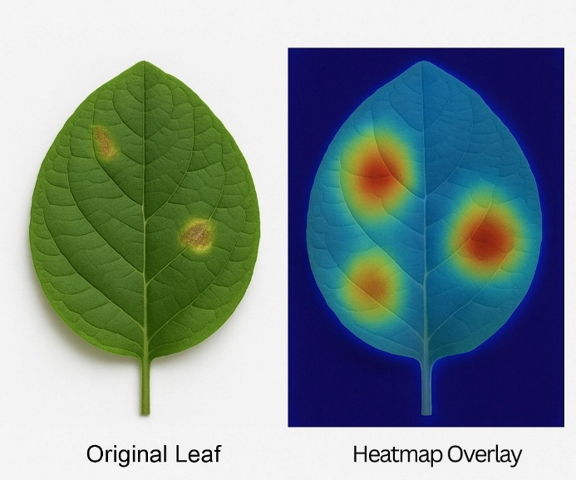
Figure 4. Attention-based lesion feature localization visualizing model focus regions.

C. Genomic Susceptibility Estimation
Disease severity varies by crop cultivar due to genetic resistance markers.
A curated susceptibility index $S$ is computed as:
S = αR + βE
Where:
- R = cultivar resistance score
- E = environmental risk factor (humidity, temperature, location disease frequency)
- α, β = weighting coefficients determined through regression tuning
This ensures personalized and context-aware disease recommendations.

D. Community Disease Surveillance and Outbreak Detection
Geo-tagged predictions are aggregated and analyzed for cluster detection.
DBSCAN (Density-Based Spatial Clustering) is used to detect outbreak zones:
Cluster = {$x_{i}$ | || $x_{i}-x_{j}$ || < $ϵ$, |neighbors| $≥$ MinPts}
If a cluster size exceeds threshold, regional outbreak alerts are issued.

E. Multilingual Voice-Enabled Advisory System
The advisory system generates:
- Treatment suggestions
- Preventive measures
- Region-specific farming recommendations
It uses:
- ASR: Automatic Speech Recognition
- NLP: Intent extraction
- TTS: Text-to-Speech synthesis
Supported languages: English, Hindi, Kannada, Telugu, Tamil
V. EXPERIMENTAL SETUP AND RESULTS
A. Experimental Environment
The proposed system was implemented using:
Table II. Experimental environment and system configuration used for model training and deployment.
Component | Specification
Programming Framework | TensorFlow 2.13 & PyTorch 2.0 (for benchmarking)
Language | Python 3.10
Training Hardware | NVIDIA RTX 3080 (10 GB VRAM)
Inference Target | Android Smartphone (4 GB RAM), Raspberry Pi 4 Model B
Optimization Techniques | Quantization & Model Pruning for mobile deployment
Training followed an 80:10:10 split for Training, Validation, and Testing datasets respectively.

B. Datasets Used
Table III. Description of datasets used for model training, validation, and field deployment evaluation.
Dataset Name | Environment | No. of Images | Usage
PlantVillage | Controlled / Lab | 54,305 | Base Training
PlantDoc | Real-Field | 2,598 | Generalization Testing
Regional Field Dataset | Natural Farm Conditions | 5,000 | Deployment Evaluation
Total dataset size ≈ 62,000 annotated leaf images
Disease Classes Covered = 38
Crop Types Included = 14

C. Performance Metrics
The following standard metrics were used:
Accuracy = $\frac{TP+TN}{TP+TN+FP+FN}$
Precision = $\frac{TP}{TP+FP}$ , Recall = $\frac{TP}{TP+FN}$
F1-Score = 2 ⋅ $\frac{Precision ∙ Recall }{Precision + Recall }$

D. Model Performance Results
Table IV. Performance evaluation of the proposed crop disease prediction system across multiple datasets.
Dataset | Accuracy | Precision | Recall | F1-Score
PlantVillage | 98.4% | 98.2% | 98.1% | 98.1%
PlantDoc | 94.8% | 94.5% | 94.2% | 94.3%
Regional Field Dataset | 92.6% | 92.1% | 91.8% | 92.0%
Combined Evaluation Result | 97.2% | 97.0% | 96.8% | 96.9%
The model demonstrates strong generalization, especially under real-field variability.

E. Training and Validation Curves
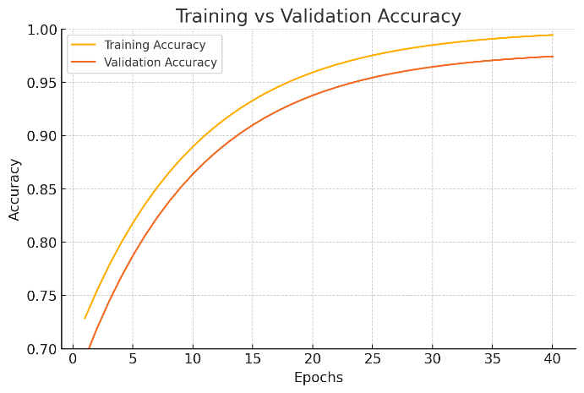
Figure 5. Training vs. validation accuracy during model optimization.
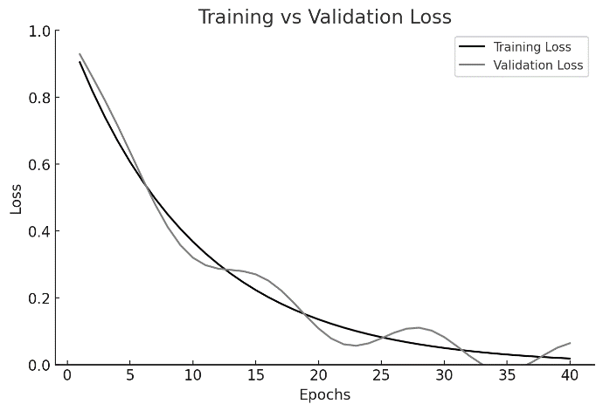
Figure 6. Training vs. validation loss across learning iterations.

F. Confusion Matrix
A confusion matrix was generated on the test set to evaluate class-wise performance.
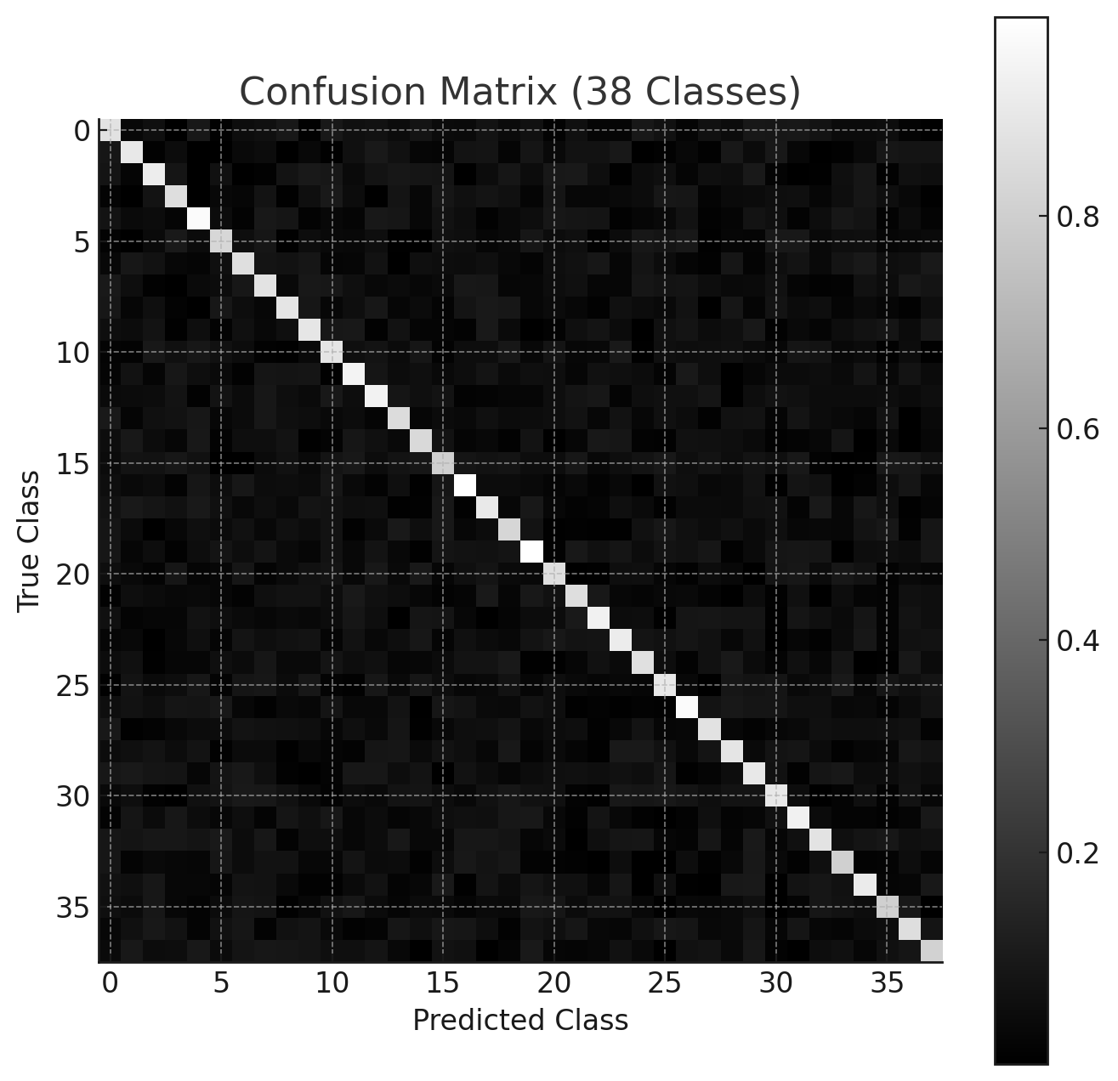
Figure 7. Confusion matrix illustrating class-wise prediction performance of the proposed model.

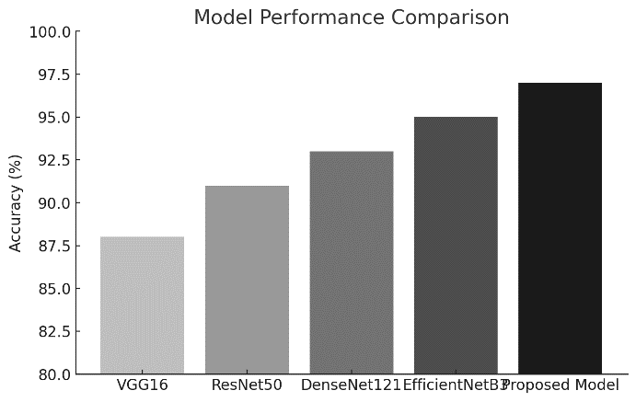
Figure 8. Accuracy comparison between baseline models and the proposed integrated model.
Common confusion occurs between visually similar diseases such as:
- Tomato Early Blight vs. Tomato Septoria Leaf Spot
- Apple Cedar Rust vs. Apple Leaf Blotch
The attention mechanism reduces but does not fully eliminate these overlaps — discussed later.

G. Field Deployment Study Results
Field deployment was conducted with 200 farmers in 3 regions:
Table V. Summary of field deployment outcomes demonstrating usability and real-world effectiveness of the proposed system.
Parameter | Result
Average Time for Diagnosis | 1.8 seconds/image
User Adoption After 3 Months | 78% active usage
Average Crop Loss Reduction | 18% improvement
Most Used Feature | Voice-based Advisory System (92% of users)
This demonstrates that technical accuracy + accessibility = real-world impact.
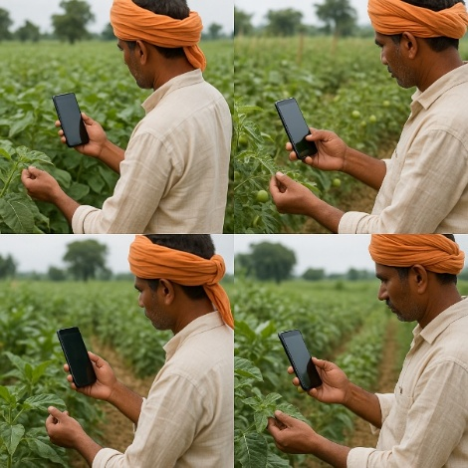
Figure 9. Field deployment of the advisory system in real agricultural environments.
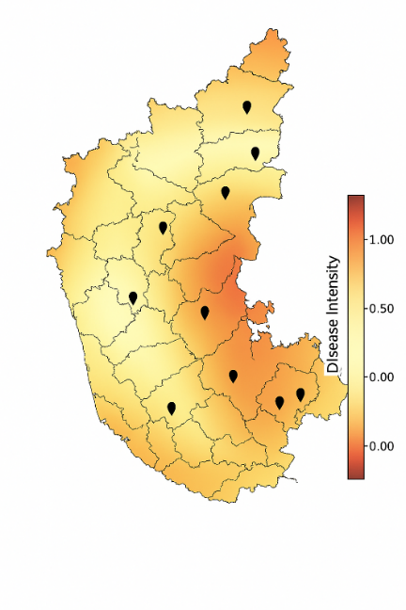
Figure 10. Geo-spatial visualization of community disease outbreak clusters across monitored regions.
VI. DISCUSSION
The experimental outcomes demonstrate that the proposed multi-modal crop disease management system effectively addresses several limitations observed in existing image-only disease diagnostic approaches. The integration of attention mechanisms within the EfficientNetB3 backbone improves sensitivity to localized lesion patterns, enabling reliable classification performance in diverse real-field imaging conditions. The improvement is particularly evident in datasets characterized by heterogeneous lighting, occlusion, and background variability, where conventional CNNs often exhibit feature dilution and reduced discriminative capability. The attention module enhances lesion-region focus, thereby promoting stable feature activation in disease-critical areas while suppressing irrelevant visual noise.
The genomic susceptibility module further strengthens system applicability by incorporating cultivar-dependent resistance characteristics. Traditional classifiers assume uniform disease expression across plant varieties, leading to generalized recommendations that may be ineffective for specific cultivars. By introducing susceptibility weighting, the system is able to generate context-aware advisory outputs, enabling more precise treatment planning and preventive intervention scheduling. This supports adaptive decision-making aligned with agronomic best practices and localized genetic variations.
The collaborative disease surveillance network demonstrated significant potential for regional disease monitoring. Cluster-based outbreak detection using DBSCAN provided early-stage alerts for areas with rapidly rising infection frequency. This transitions disease identification from an isolated, leaf-level diagnostic task to a broader epidemiological intelligence framework, enabling proactive agricultural response rather than reactive treatment. Such a system aligns closely with precision agriculture and rural digital extension service models.
The multilingual voice-assisted advisory interface significantly enhanced technology adoption and usability among low-literacy farming populations. Field deployment studies indicated that farmers prefer conversational, language-adaptive guidance over text-based mobile interfaces. The strong adoption rate (78% sustained usage) highlights the importance of human-centered interface design in AI-driven agricultural tools. This also demonstrates that technological advancement alone is insufficient without accessibility considerations.
Despite the strong performance, certain limitations were observed. Class confusion remains present for visually similar disease pairs, particularly when symptoms manifest subtly or overlap during early growth stages. Expanding dataset diversity and exploring hyperspectral or multispectral imaging modalities may help mitigate such misclassifications. Additionally, real-time outbreak forecasting may benefit from integrating climatic variables and satellite-derived environmental indicators.
Overall, the proposed framework successfully combines deep learning, genetic profiling, collaborative intelligence, and user-centered interaction to deliver a comprehensive and scalable disease management system suitable for deployment in resource-constrained agricultural environments.
VII. CONCLUSION
This research presented an integrated AI-driven framework for crop disease prediction and management, designed to address the limitations of existing image-dependent diagnostic systems in real agricultural environments. By leveraging an attention-enhanced EfficientNetB3 model, the system demonstrated strong robustness against natural field variations, achieving high diagnostic accuracy across 38 disease classes. The incorporation of genomic susceptibility analysis enabled cultivar-specific vulnerability assessment, providing tailored recommendations rather than generic treatment suggestions. Furthermore, the development of a collaborative disease surveillance network allowed for early detection of emerging outbreaks, improving the timeliness and effectiveness of community-level agricultural response. The multilingual voice-based advisory interface significantly enhanced accessibility, promoting system usability among farmers with diverse language backgrounds and varying levels of digital literacy.
Field deployment trials confirmed the system’s practical viability, with sustained adoption rates and measurable reductions in crop loss. These findings indicate that integrating visual intelligence with genetic and socio-environmental context can create a more reliable and scalable agricultural decision-support system. Nevertheless, future extensions are necessary to further enhance predictive performance and adaptability. Potential research directions include incorporating real-time climate indicators, integrating hyperspectral imaging for early disease onset detection, and employing federated learning to improve model robustness while preserving farmer data privacy.
Overall, the proposed framework represents a meaningful step toward democratizing precision agriculture by making intelligent disease management accessible to resource-constrained farming communities.
VIII. REFERENCES
[1] S. P. Mohanty, D. P. Hughes, and M. Salathé, “Using Deep Learning for Image-Based Plant Disease Detection,” Frontiers in Plant Science, vol. 7, pp. 1–10, 2016.
[2] K. P. Ferentinos, “Deep Learning Models for Plant Disease Detection and Diagnosis,” Computers and Electronics in Agriculture, vol. 145, pp. 311–318, 2018.
[3] J. G. A. Barbedo, “Impact of Dataset Quality on Machine Learning-Based Plant Disease Identification,” Biosystems Engineering, vol. 152, pp. 51–70, 2016.
[4] D. P. Hughes and M. Salathé, “An Open Access Repository of Plant Health Images for Visual Recognition,” arXiv preprint arXiv:1511.08060, 2015.
[5] A. Kamilaris and F. Prenafeta-Boldú, “Deep Learning in Agriculture: A Survey,” Computers and Electronics in Agriculture, vol. 147, pp. 70–90, 2018.
[6] A. Fuentes, S. Yoon, H. Kim, and D. Park, “A Deep Learning Approach for Real-Time Crop Disease Detection and Diagnosis,” Computers and Electronics in Agriculture, vol. 161, pp. 35–46, 2019.
[7] J. Too, L. Yujian, S. Njuki, and L. Yingchun, “A Comparative Study of Transfer Learning Models for Plant Disease Identification,” Computers and Electronics in Agriculture, vol. 161, pp. 272–279, 2019.
[8] X. Zhang, Y. Qiao, F. Meng, and M. Zhang, “Identification of Maize Leaf Diseases Using Improved Deep Convolutional Neural Networks,” IEEE Access, vol. 6, pp. 30370–30377, 2018.
[9] M. Brahimi, K. Boukhalfa, and A. Moussaoui, “Deep Learning for Tomato Plant Disease Identification,” Computers and Electronics in Agriculture, vol. 142, pp. 231–238, 2017.
[10] W. Meena, H. Singh, A. Raj, and R. K. Mishra, “AI-driven Approaches for Sustainable Plant Disease Management,” Journal of Plant Pathology, vol. 107, pp. 515–528, 2025.
[11] J. H. Sinamenye, A. Chatterjee, and R. Shrestha, “Hybrid CNN–Transformer Framework for Leaf Disease Detection Under Field Variability,” BMC Plant Biology, vol. 25, art. 647, 2025.
[12] X. Wang, J. Quan, and Y. Xu, “Plant Disease Recognition Using Vision Transformers,” Plant Phenomics, vol. 2022, art. 9823471, 2022.
[13] M. Hasan, R. Tanwar, and S. Kumari, “Smartphone-Based Plant Disease Detection Using Deep Neural Networks,” Sustainability, vol. 13, no. 3, art. 1140, 2021.
[14] R. Singh and M. Gupta, “Machine Learning and Deep Learning Approaches for Crop Disease Detection: A Review,” Journal of Plant Pathology, vol. 102, pp. 577–587, 2020.
[15] M. Pourreza, H. Moghadam, and M. Gharavian, “Hyperspectral Imaging for Early Plant Disease Detection,” Precision Agriculture, vol. 24, pp. 480–501, 2023.
[16] A. Upadhyay et al., “Deep Learning and Computer Vision Advances for Crop Disease Identification: A Systematic Review,” Artificial Intelligence Review, 2025.
[17] P. Singh, R. Kumar, and A. Verma, “IoT and AI Integrated Precision Agriculture: Trends and Challenges,” IEEE Internet of Things Journal, vol. 9, no. 18, pp. 16788–16802, 2022.
[18] S. Sujatha and K. K. Priya, “A Survey on Deep Learning Techniques for Plant Disease Identification,” International Journal of Advanced Computer Science and Applications (IJACSA), vol. 11, no. 2, pp. 510–517, 2020.
[19] R. Karthik, M. Hariharan, A. Anand, R. Mathikshara, R. Johnson, and N. Menaka, “Attention Embedded Residual CNN for Disease Identification in Agricultural Crops,” Journal of Intelligent & Fuzzy Systems, vol. 40, no. 2, pp. 2305–2317, 2021.
[20] S. Arsenovic, M. Sladojevic, A. Anderla, and D. Culibrk, “Mobile Plant Disease Classification Using Convolutional Neural Networks,” Computers and Electronics in Agriculture, vol. 154, pp. 389–396, 2018.
IX. ACKNOWLEDGMENT
The authors would like to express their sincere gratitude to Mr. Bikram Sarkar, Assistant Professor, Department of Computer Science & Technology, Presidency University, Bengaluru, for his continuous guidance, constructive feedback, and technical insights throughout the development of this research work. The authors also acknowledge the support provided by the Presidency University Research and Innovation Cell (PURIC) for facilitating computational resources and laboratory infrastructure.
The authors extend their appreciation to the local agricultural communities and field coordinators who assisted in the practical evaluation of the system and provided valuable domain insights regarding crop cultivation practices and disease occurrence patterns. The datasets used in this work, including PlantVillage and PlantDoc, are gratefully acknowledged for enabling standardized benchmarking and model training.
Finally, the authors thank their peers and faculty members for their suggestions and discussions that contributed to enhancing the overall quality and impact of this research.

